|  |  |
| --- | --- |
| Hands-on Activity 1.1 : SQL Data Definition Language Commands | |
| Belocora, John Rome A. | 09/15/2023 |
| CPE 011-CPE21S3 | Ms. Marjorie Escanan |

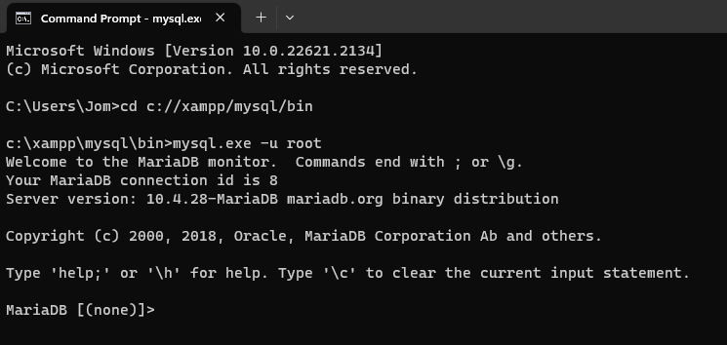

Show databases: (The show databases shows the databases created)

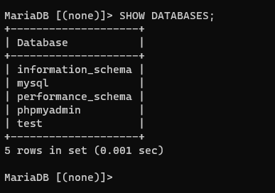

Creating Database “vehiclesdb”: (This part will create a database named “vehiclesdb”)

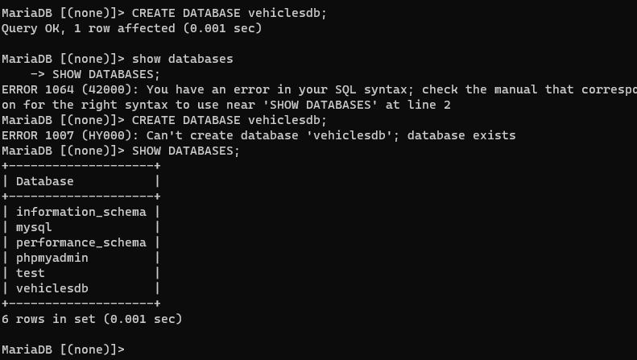

Removing database “vehiclesdb”: (The remove data base uses the “DROP” command line)

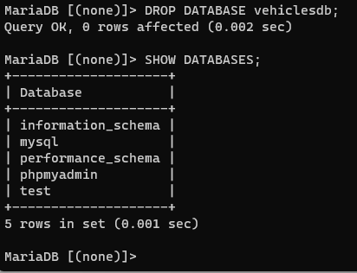

Using a Database: (The “USE” is like a SELECT command line to use the database)

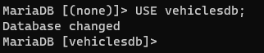

Creating another Table: (This part will create another table vehicles)

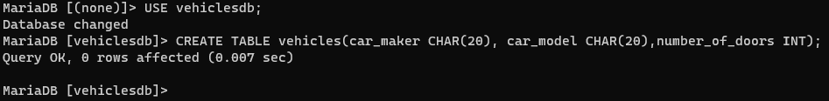

Showing the Created Tables: (This part will output the created tables that you make)

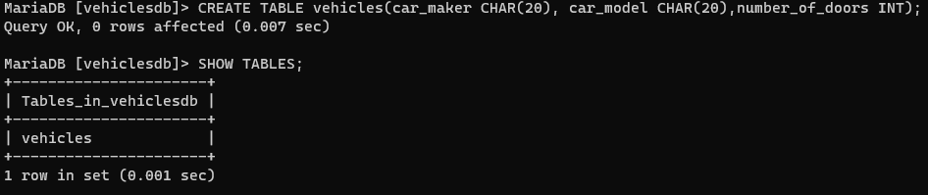

Structure of a particular table:

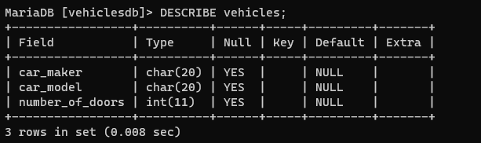

Altering the table structure:

* ALTER TABLE vehicles RENAME vehicle; and DESCRIBE vehicle;

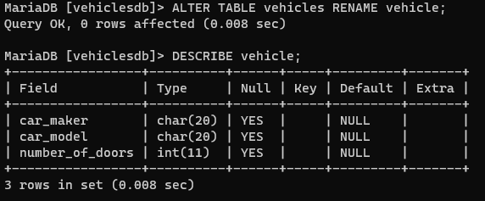

* ALTER TABLE vehicle MODIFY number_of_doors INT(2); and DESCRIBE vehicle;

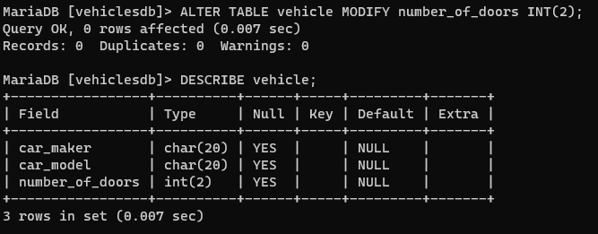

* ALTER TABLE vehicle ADD year_model DATE; and DESCRIBE vehicle;

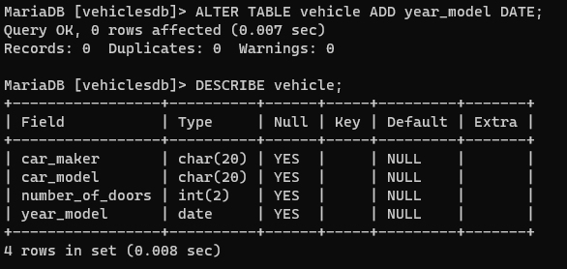

* ALTER TABLE vehicle CHANGE year_model year_released DATE; , ALTER TABLE vehicle DROP year_model; and DESCRIBE vehicle;

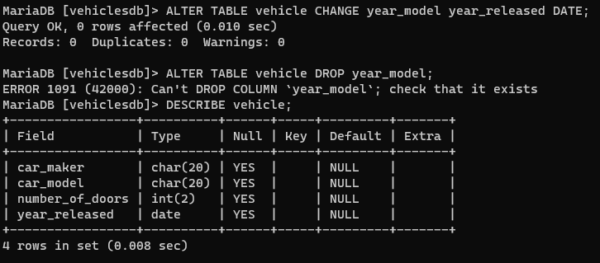

* ALTER TABLE vehicle RENAME vehicles;

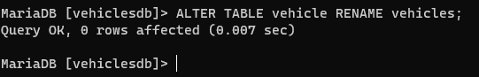

Supplementary Activity:

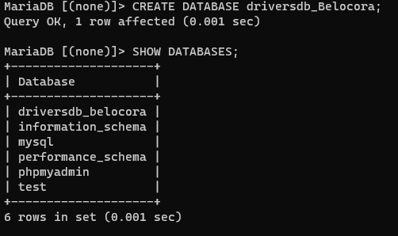

* Creating the table drivers:



* Creating the table vehicles:



* Tables created:

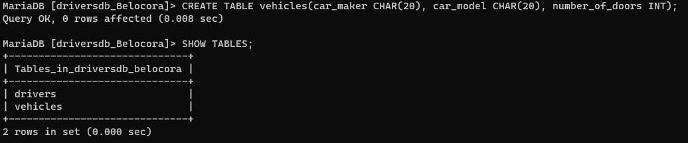

* Structures of each tables:

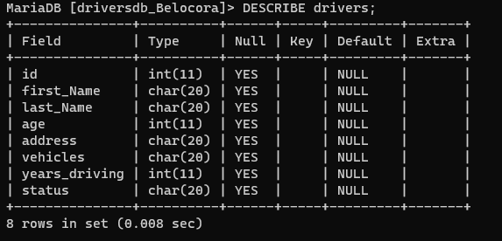

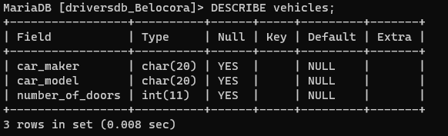

* Adding the Drivers_license into the Field Drivers.

(int)

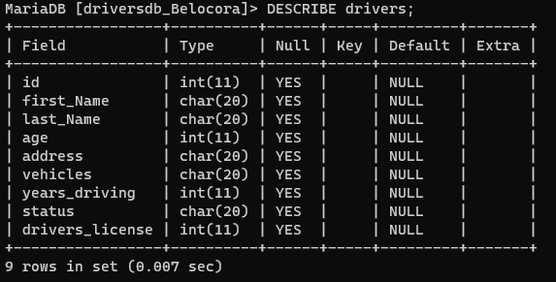

(char)

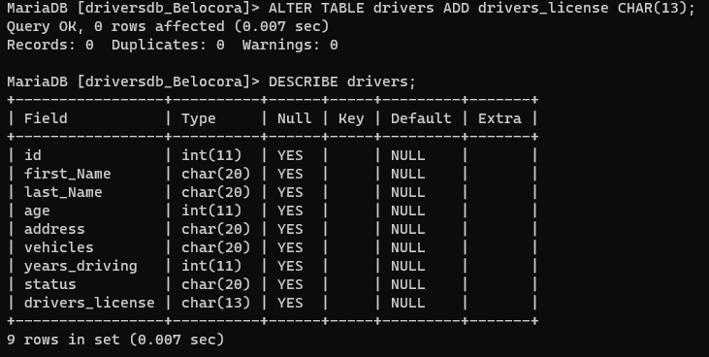

* Removing the field vehicles from the drivers table

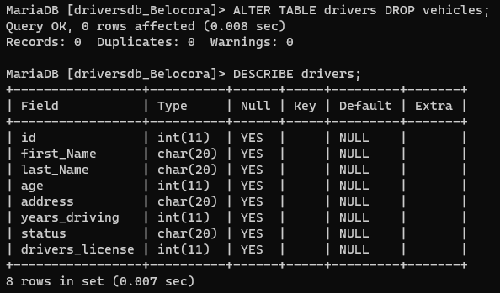

* Structures created in the table:

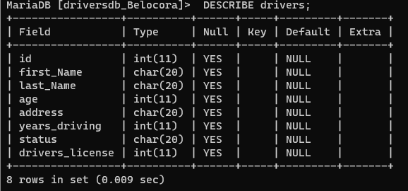

|  |  |  |
| --- | --- | --- |
| Tasks | Syntax | Actual SQL Command Used |
| Create a new database | CREATE DATABASE | CREATE DATABASE driversdb_Belocora; |
| Create a table named drivers | CREATE TABLE drivers | CREATE TABLE drivers(id INT, first_Name CHAR(20), last_Name CHAR(20), age INT, address CHAR(20), vehicles CHAR(20), years_driving INT, status CHAR(20)); |
| Create a table named vehicles | CREATE TABLE vehicles | CREATE TABLE vehicles(car_maker CHAR(20), car_model CHAR(20), number_of_doors INT); |
| Add a new column drivers_license | ALTER TABLE drivers ADD drivers_license | ALTER TABLE drivers ADD drivers_license INT; |
| Change the data type of drivers_license | ALTER TABLE drivers CHANGE drivers_license | ALTER TABLE drivers CHANGE drivers_license CHAR(13); |
| Remove the field vehicles from the drivers table | ALTER TABLE drivers DROP vehicles | ALTER TABLE drivers DROP vehicles; |

Questions:

1. Try and run your SQL Commands in opposite case or in mixed cases (ex. SHOW TABLES – show tables). What is the output and what is the feature of SQL that you can see in doing this task?

- I used the “SHOW DATABASES” command in opposite case and it still worked. I think that the SQL will do the command as long as it is given the right Command or Syntax.

1. Attempt creating a database with a similar name, but with varying capitalization. What is the result? Why?

* It showed an error which it says that the database already exist. It is because it still has the same name which also means it has the same value but they only vary or differ in capitalization.

1. Attempt creating a table with two similar names. What is the result? Why?

* It showed an error which says that the table already exist. It won’t create another table with similar name since it already exist.

1. Try creating two fields in table with two similar names with same then with different data types. What are the results? Why?

* It shows a output that the field has a Duplicate column name. Because you cannot create a two fields with the same name since it cannot be duplicated or else the attributes of the fields will not work properly.

1. From the output of Question #4. How does MySQL perform the check to determine the output the result in Question#4? Does its data type matter?

* The MySQL will first check if it has the similar name then if yes, it would show an error that it is a duplicate name. Yes, it’s data type matter since the attributes concluded in the field represents its value.

1. Why do you think the keywords in SQL commands written in the instructions of this manual and online references are capitalized? Does it affect the query in anyway? Why?

* Capitalizing SQL keywords makes them stand out and easily recognizable within a query. The Capitalization of SQL keywords does not affect the functionality or execution of a query in any way since SQL is not a case-sensitive when it comes to keywords and identifiers.

Conclusion:

In conclusion, SQL command lines are powerful tools for interacting with and managing relational databases. They provide a direct and flexible means of querying, updating, and maintaining data. Here are some key takeaways about the use of SQL command lines.